***Pediatric Population Analysis Report***

***Healthcare Analytics - MGS 670***

**Report by:**

**Michael Dubin**

**Pushkaraj**

**Roli N**

**Zhi Ling Ni**

**Table of Contents**

**Introduction** **2**

**“Health” for the Pediatric Population** **3**

**Pediatric Population** **Risk Assessment 5**

**P****reventative Services** **Utilization 7**

**Identify the patients who are at significant risk of becoming unhealthy adults** **11**

**Identifying comorbidities that makes pediatric patients high risk in their adulthood** **12**

**What steps must be taken to ensure health in the population** **13**

**How are we measuring success?** **15**

**Citations** **18**

# Introduction

As stated in Healthy People 2020 objectives, promoting access to effective health and health-related services is essential in well-being. For this objective, to have a long-standing positive impact on reducing costs & improving quality and access, this should be instituted during the pediatrics years. Pediatric health is a state of physical, mental, intellectual, social, and emotional wellbeing and not merely the absence of disease or infirmity. Healthy children live in families, environments, and communities that provide them with the opportunity to reach their fullest developmental potential. Children cannot achieve optimal health alone because they are dependent upon adults and the community to provide them with an environment where they can learn and grow healthy. Maternal health status, habits, and environment during and even before pregnancy profoundly impact a child's health and wellbeing. Thus, achieving optimal child health depends on optimizing the health and wellbeing of a child's mother. When children's health is nurtured and supported, physical and mental abuse is absent, or other intentional childhood trauma. There exist opportunities to gain habits that support good health during childhood. The stage is set for healthy adulthood less likely to include chronic health problems such as for overweight/obesity, poor oral health, diabetes, and other chronic physical and mental health problems.

These years are critical in identifying possible conditions that may promote future risk. This risk not only provides us with a current snapshot of the child’s development, but also a possible indication of future health and well-being. Conducting this can be very challenging given the many different factors that play into analyzing pediatric health. In this report, we will provide a detailed analysis on each of these factors. We will investigate what pediatric health is from both a parent and pediatrician viewpoint. Utilizing real data provided, we will develop a method for assigning risk to patients. We will identify patients who have accessed the most preventative services, as well as patients who have accessed the least preventative services. Utilizing the knowledge from our Medical Advisor, Alex Gosh, we will identify patients who are at significant risk of becoming unhealthy adults. We then will suggest steps to take to ensure health in this population – including a possible incentive structure and metric for success.

------------------------------------------------------------------------------------------------------------

# “Health” for the Pediatric Population

We defined a healthy state in children based on two perspectives: one from the pediatric and another from the parent's perspective.

Based on our readings, research, and meeting with our advisor, we took into consideration the following factors that define the healthy state:

1. **ACG score**: that measures the morbidity rate in the large population and scores a patient on a scale of 0 to 5 where 5 signifies high morbidity rate and 0 signifies low morbidity rate.
2. **Compliance and noncompliance:** We believe the patients who have undergone all preventive measures as advised by their pediatrician are healthier than the counterparts because they have shielded themselves from fatal diseases/conditions like tuberculosis, handicapped for life long, measles, and chickenpox.
3. **Follow-ups:** A decrease in the number of follow-ups of a curable ailment is a good sign of health improvement. Regular follow-ups for chronic conditions such as diabetes or asthma signify a controlled state and awareness, eventually leading to a healthy condition.
4. **Child abuse:** Pediatricians consider child abuse a significant factor in defining a healthy state because it has a fatal effect on kids' growing brains. The kid who has a damaged childhood grows with psychological ailments that could burden society in the future.
5. **Cognitive development**: we looked into ADHD ( Attention deficit hyperactivity disorder), neurodevelopmental disorders. Although it subsides as the child grows an early detection can prevent it from aggravating at the age of 7-8 years and will help the child concentrate on the activities, resulting in his overall development
6. **Physical growth:** We specifically looked into BMI. It helps find the underweight, obese and overweight conditions that can further help prevent chronic diseases like diabetes in the obese or overweight kids and marasmus or kwashiorkor conditions in underweight kids.
7. **Robust muscle and bone:** They are essential factors to define the healthy state as the child undergoes a couple of growth spurts from the time he is born until he turns 18. So a strong musculature and posture itself will indicate a well-being state.

A healthy state from a parent's point of view is trivial and easy to follow. Because parents base their judgment on day-to-day activities such as good performance in school, engaging in physical activity and extracurricular activity, not missing school, eating healthy, etc.

Child health is foundational to adult health and well-being. Because kids are the future of society, they are as tender and soft as clay that is easy to shape and mold. Early intervention can prevent many conditions from occurring, such as diabetes and psychological ailments that could later become a burden on society. So, why not keep a check now rather than let such conditions aggravate when we know it's curable and preventable.

We will now discuss the factors that will help define the healthy state in kids and guide us to risk factors based on the data provided to us.

------------------------------------------------------------------------------------------------------------

# Assigning Risk to the Pediatric Population

In order to assign risk to the pediatric population we first need to understand the important features of the population that makes someone a high risk patient or a low risk patient. We first looked at the high level population statistics. Our population age ranges from 0 - 18 years Gender ratio is almost 1. And most of the population declined to express their ethnicity and race and we do not have sufficient confidence on building our prediction on these features. At least 70% of the population belongs to the Buffalo and Niagara Falls region.

The ACG risk score distribution has a bell shaped curve where 90% of the population belongs to the 1, 2, or 3 risk scores.

From exploratory analysis we find patients with high ACG risk scores have a high median number of problems.

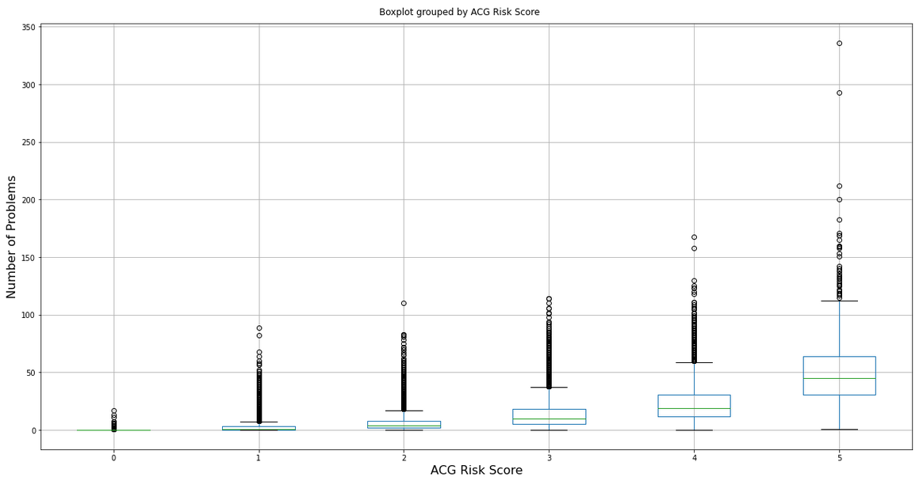Opposite to that negative relationship true between Age and ACG Risk score.

As we can see that higher risk populations are likely to have lower Age of the patients. Even though this relationship is identifiable from the above plot it does not indicate a causal relationship between Age and ACG Risk score.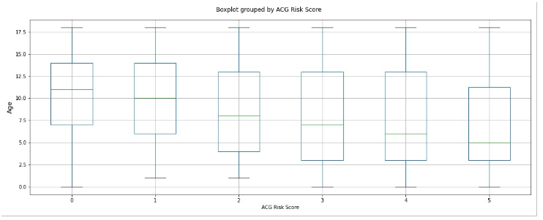

The Pearson correlation plot identifies the linear relationship between two variables. The below plot shows Pearson correlation values between different variables and ACG Risk score.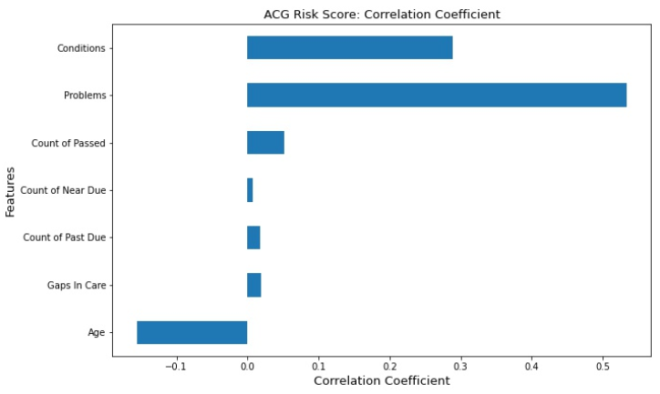

This plot shows a strong positive correlation between ACG Risk score and the number of conditions and the number of problems.

In order to now find patient conditions that make them high or low risk we make use of the three different machine learning algorithms called logistic regression, decision tree, and random forest. After solving a classification problem using these three algorithms we find 12 significant conditions in the pediatric population that is listed in the table below.

|  |  |
| --- | --- |
| **Top 12 Significant Conditions in the Pediatric Population** | |
| Otitis Media | Sleep Apnea |
| Perinatal Conditions | Leukemia |
| Epilepsy | Hypertension |
| RA | Immunodeficiencies |
| Asthma | Renal Failure |
| Diabetes | Mental Disorders |

---------------------------------------------------------------------------------------------------------------------

# Preventative Services Utilization

Identifying the pediatric patients' preventative services utilization rate is very important in further understanding the “health” of this population. As stated earlier, proper interventions in the childhood development stage, allows for health and well being in adult years. In order to establish this precedent, we must be proactive early. Pediatric patients should regularly and continuously undergo preventive services. Some of the most highly used and effective preventative measures include vaccinations, well visits, screenings, etc. Although these measures are not perfect in maintaining quality health in the pediatric years, they are effective in controlling costs, improving quality of care, and access to care.

As we further analyzed this data set, we looked to identify a measure that would provide us with a metric for measuring the utilization of preventive services. The best metric to measure this would be an individual's *count of past due* services. These are preventative services that have been recommended by the physician but have not been completed within the necessary time frame. For example, patients should be vaccinated for Meningococcal at a certain age. If the patient is not vaccinated by that age, this preventative service is flagged at *past due*. For patients who have no *past due* preventative services, they are classified as high utilizers. Meaning they have received all the recommended preventive services. For patients who have one or more *past due* preventative services, they are classified as low utilizers. Meaning they have not received all the recommended preventative services in time.

After utilizing several models, we decided that the random forest model provided the most statistically significant factors that were associated with low and high utilizers. Based on the model, the top three most significant features were race, ACG score, and zip code. Using this critically important information we then proceeded to analyze these features in the data set.

In the feature analysis of race, we identified a large disparity in the pediatric population between whites and multi racial patients. This was about a 30% disparity between the high utilizers between the groups. This is a cause for concern as there can be a magnitude of reasons for this disparity. One of the largest reasons for this racial disparity can get traced back to the important framework of the social determinants of health. Further analysis is needed to understand this disparity in greater details. This would allow for an implementation of an intervention to reduce this disparity.

|  |  |  |  |  |
| --- | --- | --- | --- | --- |
|  | **Count** | | **Percent** | |
| **Race Risk Score** | **High Utilizer** | **Low Utilizer** | **High Utilizer** | **Low Utilizer** |
| White | 15,131 | 7,993 | 65% | 35% |
| Asian | 214 | 165 | 56% | 44% |
| Native Hawaiian | 22 | 18 | 55% | 45% |
| American Indian | 11 | 9 | 55% | 45% |
| Other | 136 | 138 | 50% | 50% |
| Black or African American | 557 | 586 | 49% | 51% |
| Multi | 24 | 47 | 34% | 66% |

In the feature analysis of ACG risk score, we identified two main populations (ACG risk score 0 and ACG risk score 5) that had very low utilization rates. These results can be shown in the chart below. There could be several reasons for these findings. For patients in the ACG risk score group of 0, these patients can be seen as very low risk. These patients are healthy, with very few diseases, procedures, and treatments. Therefore, these patients may feel invincible, which in hand may prompt them to not feel inclined to utilize all the preventive services recommended by their provider. For patients in the ACG risk score group of 5, these patients are seen as very high risk. They aren't healthy, and have many diseases, procedures, and treatments. One possible reason for lower utilization for this population, could be a lack of awareness or motivation. These individuals may not necessarily be aware of the services that their provider has suggested, due to the high amount of procedures being performed currently. In addition, patients may feel unmotivated to go to their provider due to the fear of further diagnosis.

|  |  |  |  |  |
| --- | --- | --- | --- | --- |
|  | **Count** | | **Percent** | |
| **ACG Risk Score** | **High Utilizer** | **Low Utilizer** | **High Utilizer** | **Low Utilizer** |
| 0 | 897 | 762 | 54% | 35% |
| 1 | 10,497 | 4,482 | 70% | 44% |
| 2 | 12,345 | 5,486 | 69% | 45% |
| 3 | 11,293 | 5,498 | 67% | 45% |
| 4 | 1,982 | 1,135 | 64% | 50% |
| 5 | 396 | 312 | 56% | 51% |

In the feature analysis of zip code, we delve further into the social determinants of health. We utilized zip codes associated with over five hundred patients. With this information, we found the top three and bottom three zip codes associated with preventive services utilization. While the findings can be very trivial to understand, we need to look at possible trends between the zip codes. For example, in the zip codes 14304 and 14120, they are neighboring postal codes in Niagara County. With this critical information, we then would want to identify what are the possible reasons that can be associated with this high level of utilization. Are these neighboring zip codes implementing certain measures for a high compliance and utilization of preventative services? Are there any social determinants of health reasons that can be associated with a very high utilization rate? Additionally these questions are going to need to be addressed with the population of low utilizers. Similar to the high utilizers, the zip codes of 14212 and 14211 are neighboring postal codes. The significance of neighborhood zip codes can be due to a larger regional issue in that area.

|  |  |  |  |  |
| --- | --- | --- | --- | --- |
|  | **Count** | | **Percent** | |
| **Zip Code** | **High Utilizer** | **Low Utilizer** | **High Utilizer** | **Low Utilizer** |
| 14304 | 1,229 | 307 | 80% | 20% |
| 14120 | 3,279 | 1,044 | 76% | 24% |
| 14072 | 1,388 | 465 | 75% | 25% |
|  |  |  |  |  |
| 14212 | 416 | 313 | 57% | 43% |
| 14211 | 593 | 476 | 55% | 45% |
| 14048 | 359 | 359 | 50% | 50% |

WIth the information provided based on the analysis, we will need to dig deeper into each of these disparities. We need to understand why some groups of the pediatric population utilize preventative services more than others. This can be a very tricky issue as most of the findings will be highly correlated to the pediatric patients parents.

---------------------------------------------------------------------------------------------------------------------

# Identify the patients who are at significant risk of becoming unhealthy adults

With the analysis on the important *condition* features of the pediatric population, we needed to further analyze which of these features are associated with a higher risk of becoming an unhealthy adult. This was needed as some of these features are not associated with unhealthy adult risk, rather an acute pediatric illness, such as otitis media (ear infection). To do this we reached out to our medical consultant, Dr. Alex Gosh.

During our meeting we discussed our findings of the conditions that were seen as significant in the pediatric populations health. Furthermore, Alex provided us deep insight to which of these features are significant in the patient developing into an unhealthy adult. The resulting conditions are diabetes, sleep apnea, and hypertension. Alex mentioned that diabetes is currently an epidemic in the US with more and more younger people getting type 2 diabetes. This results in an elevated risk for cardiovascular disease, high blood glucose, eye problems, nerve damage, and acute hyperglycemic crisis. All of these diseases if not monitored can land the patients in the hospital. Sleep apnea is another pediatric condition that results in hypertension, obesity, cardiovascular disease, and AFib.

---------------------------------------------------------------------------------------------------------------------

# Identifying comorbidities that makes pediatric patients high risk in their adulthood

As we discussed we have found Sleep Apnea, Diabetes, and Hypertension the most important conditions that make patients at high risk in their adulthood. To find high risk comorbidities we list most prevalent conditions that occur with each of these conditions.

|  |
| --- |
| Sleep Apnea:  Otitis Media 26.67%  Mental Disorders 15.43%  Asthma 10% |
| Diabetic type II:  Overweight and Obesity 31.58 %  Sleep Apnea 26.32%  Diabetic type I 26.32%  Mental Disorders 21.1% |
| Hypertension:  Overweight and Obesity 20%  Mental Disorders 20%  Sleep Apnea 16.6% |

# What steps must be taken to ensure health in the population

Since we are studying the pediatric population; prevention and early control are critically important for this population in long term health. Increasing investment in this population enables more and better health care for them. In this way we not only reduce the probability of our next generation becoming unhealthy adults, we can also save money and medical resources in the future. Ensuring health in an early stage can prevent more serious diseases in the future. To ensure health in the pediatric population, we suggest

* Applying a comprehensive examination to newborns. Trying to record each patient’s health conditions from the moment they were born can help providers to better understand the population’s medical history and provide us with a more complete database.
* Encouraging all patients to take annual examinations. Identify and group patients into any of these three groups: relatively lower-risk patients, chronically ill patients, high-risk patients. So we can develop different plans for each group to maximize the utilization of resources.
* Providing free teaching resources to parents. So they know how to cultivate correct healthy behaviors for their children. For instance, how to establish good eating habits.
* Working with the local community to increase the promotion of a healthy lifestyle, such as the danger of smoking and the effect secondhand smoke has on children.
* We also suggest offering small gifts to encourage patients to take annual physical examinations. For example, we can offer cartoon toothbrushes to kids and movie tickets to parents.
* Since many children have less obvious symptoms than adults, we also suggest providers to actively seek out the population, instead of waiting for patients to come to them.
* Studying from the success organization, CareMore. We can form interdisciplinary teams to ensure the health of this population. We can rely on low-cost providers to provide primary care services. Meanwhile, we can save the time of "specialists" for patients' urgent needs and hospitalization demands before, during, and after their treatments.
* Holding annual events and creative contests to attract the attention of the community. To give an example, we can hold a brainstorming contest to draw the attention of the community and raise their awareness of health. If we are lucky enough, we can collect and update health plans to better serve the population.

Implementing all these steps can prevent and manage the diseases in the pediatric population, ensure sufficient resources and adequate services, decrease morbidity and mortality, and strengthen health promotion. Eventually, we will be approaching comprehensive primary health care and Triple Aim.

# How are we measuring success?

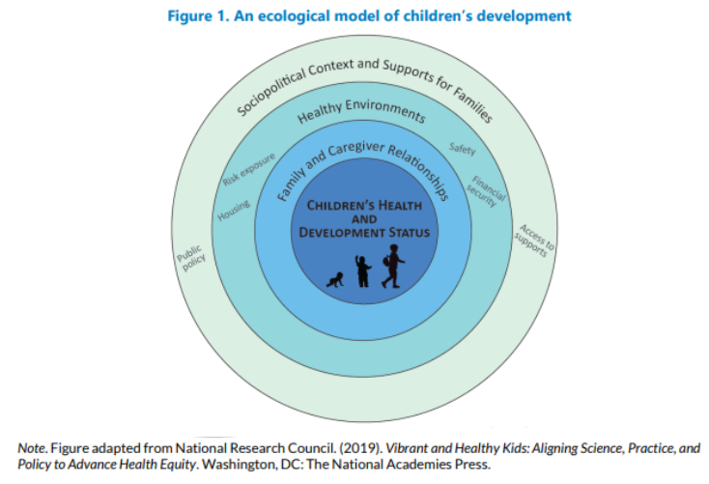

We have to take into consideration the following factors/facts before deciding the success.

* Education/Awareness: lack of awareness and education is a significant factor behind an unhealthy state.The higher the awareness, more will be the healthy state in the pediatric population.
* Differential epidemiology: Except for a subset of children with special health care needs, children are less likely than adults to have multiple comorbid conditions.
* Dependence: Parents and other caregivers play a critical role in children’s health care.
* Demographics: Children are more likely than adults to live in poverty and represent diverse racial and ethnic groups, and are less likely to have health insurance.
* Development: Physical, emotional, and cognitive development change dramatically across childhood; the needs of children at different ages may be strikingly different.

Furthermore, we can cooperate with HeathEOutcome to obtain data that can help us to measure the success of our plan. Depending on the service volume such as demographics and total users of medical service, we can evaluate:

1. the reach area of the population by analysing:

* Frequency of service interactions,
* Average duration of services,
* Adherence to scheduled patient reassessments/outreach standards,
* Community referral completion rates

1. the health access and awareness of the population by analysing:

* Percentage of uninsured patents
* Percentage of patients with regular PCP
* Medical home enrollment rate
* Average appointment wait time
* Awareness of service available, such as walking paths, health fairs

1. the strength of preventive care by analysing:

* Percentage of patients not at risk out of those who complete a health assessment
* Completion rates for specialty screenings
* Completion rates for preventive services

1. the current Healthcare utilization by analysing:

* Hospital admissions and/or ED visits per 1,000 patients
* Asthma- or other acute exacerbation-related hospitalizations
* PMPM or PMPY
* 30- 60- 90-day readmissions rates for medical group patients admitted

1. the practices to identify and compare the data of high-risk patients by using:

* ACG risk score

Besides, we believe that success can not be defined just based on quantitative analysis. It has to be based on qualitative and quantitative that helps us identify fine and gross motor, cognition and problem-solving skills, receptive and expressive language skills, and social and emotional skills.

Therefore, based on our data analysis and readings, keeping a proper and detailed track record ( EHR), following all the screening and preventive measure as advised by the pediatrician, reduction in follow-ups from the curable ailment, and regular follow-ups for a chronic condition such as diabetes, resulting in a decline in the ACG score - indications of progressing towards healthy states or already falling under the healthy state.

In addition, we also need to continually communicate with patients to measure patient satisfaction and health status. Ultimately, we need to combine all the information to determine whether we have successfully reached the Triple Aim.

Health during childhood sets the stage for adulthood. Therefore, invest in kids as they are the future of society.

Early intervention can also save the public expenditure in the future and opens gateways to the research of incurable ailments. In contrast, failure to optimize health in them can result in future burdens.

# 

# Citations

<https://buildthefoundation.org/wp-content/uploads/2019/09/Early-Childhood-Population-Measures-Scan-1.pdf>